**INTI International College Penang School of Engineering and Technology**

**3+0 Bachelor of Science (Hons) in Computer Science, in collaboration with Coventry University, UK**

**3+0 Bachelor of Science (Hons) in Computing, in collaboration with Coventry University, UK**

**Coursework cover sheet**

**Section A - To be completed by the student**

| Full Name:  Ota Kazuki | |
| --- | --- |
| CU Student ID Number:  P20012061 | |
| Semester:  **April2022** | |
| Session:  **April 2022** | |
| Lecturer:  **Nadhrah Abdul Hadi (nadhrah.abdulhadi@newinti.edu.my)** | |
| Module Code and Title:  **4067CEM Software Design** | |
| Assignment No. / Title:  **Continuous Assessment** | % of Module Mark:  **50** |
| Hand out Date:  **22nd April 2022** | Due Date:  **Task 1: 13 May 2022, by 11.59pm**  **Task 2: 1 July 2022, by 11.59pm**  **Task 3: 17 June 2022, by 11.59pm.**  **Task 4: 17 June 2022, by 11.59pm.**  **Task 5: 17 June 2022, by 11.59pm.** |
| Penalties: No late work will be accepted. If you are unable to submit coursework on time due to extenuating circumstances, you may be eligible for an extension. Please consult the lecturer. | |
| Declaration: I/we the undersigned confirm that I/we have read and agree to abide by the University regulations on plagiarism and cheating and Faculty coursework policies and procedures. I/we confirm that this piece of work is my/our own. I/we consent to appropriate storage of our work for plagiarism checking.  Signature(s): ________________________ | |

**Section B - To be completed by the module leader**

| Intended learning outcomes assessed by this work:  1. Understand and apply appropriate concepts, tools and techniques to each stage of the software development  2. Understand and apply design patterns to software components in developing new software  3. Demonstrate an understanding of project planning and working to agreed deadlines, along with professional, interpersonal skills and effective communication required for software production  5. Demonstrate an awareness of, and ability to apply, social, professional, legal and ethical standards as documented in relevant laws and professional codes of conduct such as that of the Malaysian National Computer Confederation. | | |
| --- | --- | --- |
| Marking scheme | Max | Mark |
| 1. User Story Mapping 2. Setting up a GitHub Repository 3. Creating a Class diagram and design pattern selection 4. Creating a Prototype User Interface and Usability Testing 5. Discuss the ethical issue related to the software | 20  10  30  20  20 |  |
| Total | 100 |  |

Vision

What is the problem？

1.Students are not aware of events being held at their own universities/colleges and events are not being attended.

2.The current situation is that participants and organizers have different ways of managing event information. which can lead to misdelivery of information.

How to solve?

The best way to solve the problem is to design, develop and provide a clear and solid website platform that is easy for users to use.

Who are the users？

Students are the primary target users, as well as event organizers and school officials.

If an organization outside of the school organizes the event, the organization will also be its target audience

Below is the survey I created in Google form.

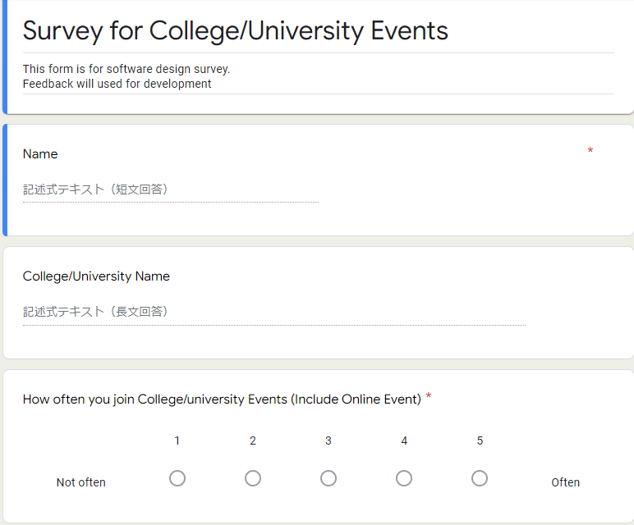

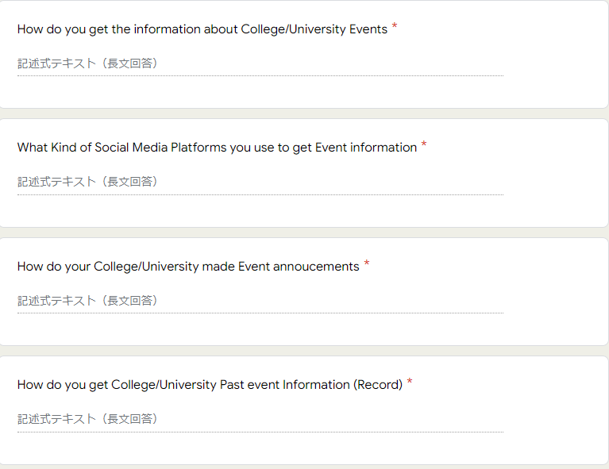

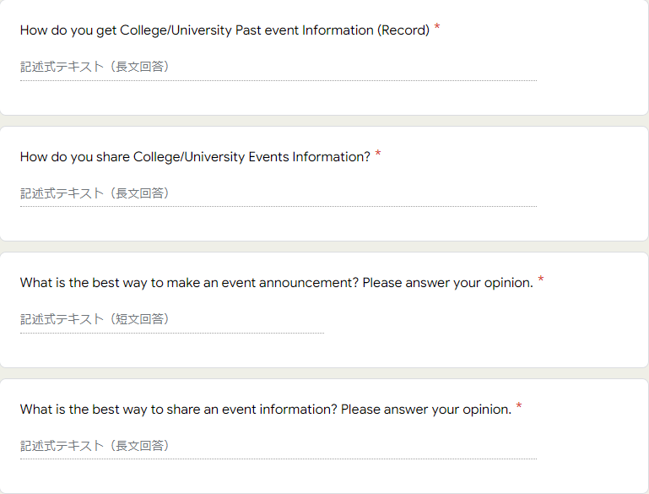

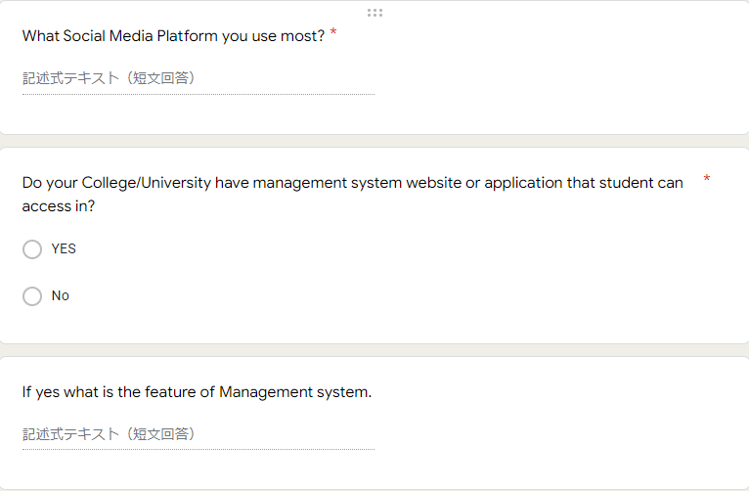

Below is the feedback I receive from the participants

For Q1~Q2

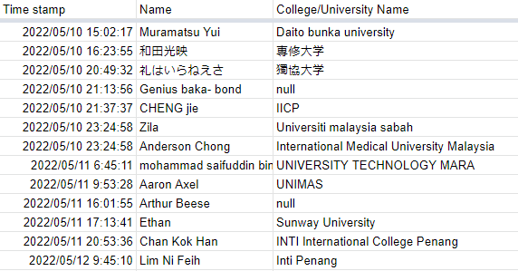

2nd row: Senshu University

3rd row: Dokkyo University

For Q3

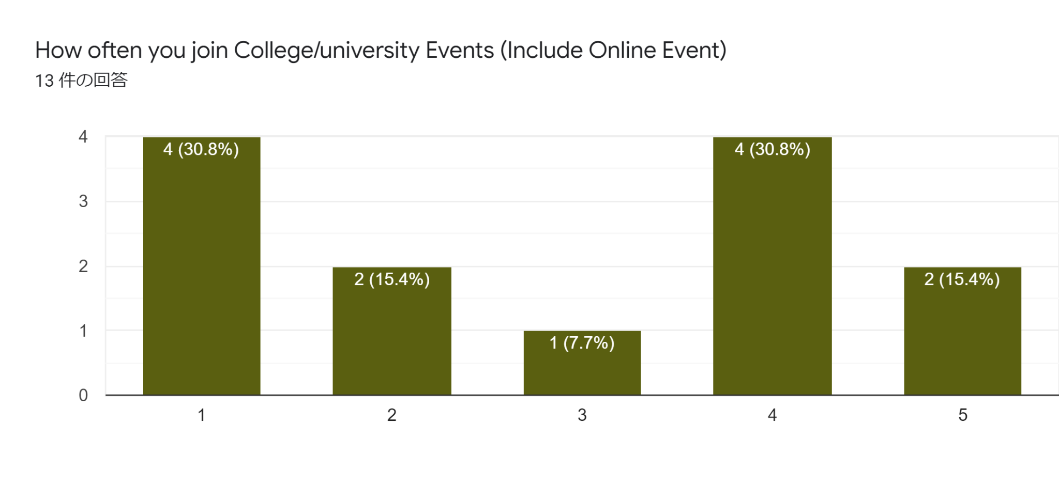

For Q4

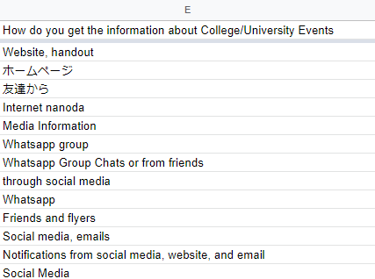

2nd row: Website

3rd row: Friends

For Q5

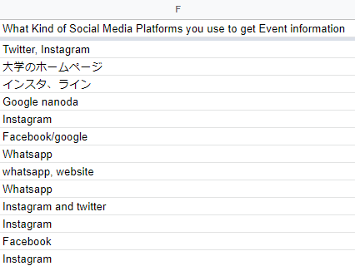

2nd row: Google

3rd row: Instagram & LINE

For Q6

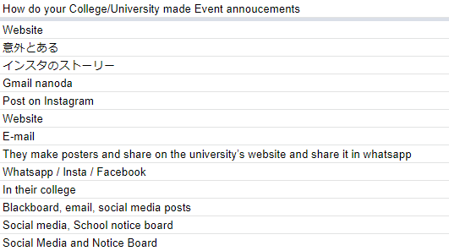

2nd row: Irrelevant answer

3rd row; Instagram story

for Q7

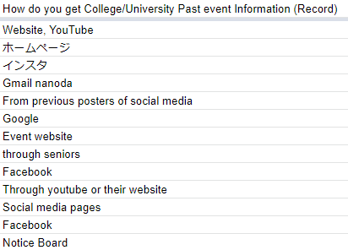

2nd row: website

3rd row: Instagram

For Q8

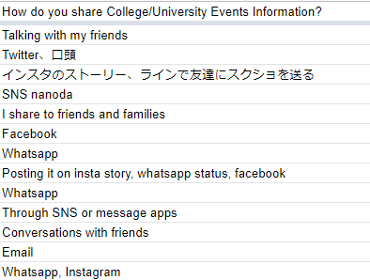

2nd row: orrally

3rd row: by instagram story or send screen shot through LINE

For Q9

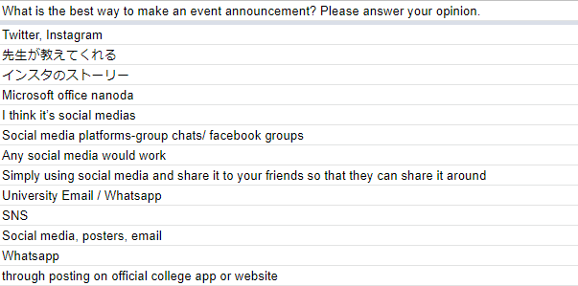

2nd row: announcement by lecturer

3rd row: instagram story

For Q10

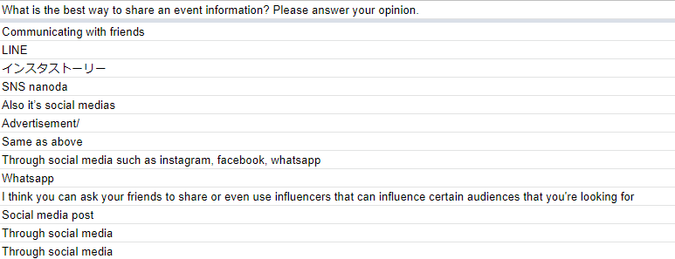

3rd row: Instagram story

For Q11

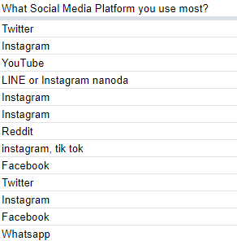

For Q12

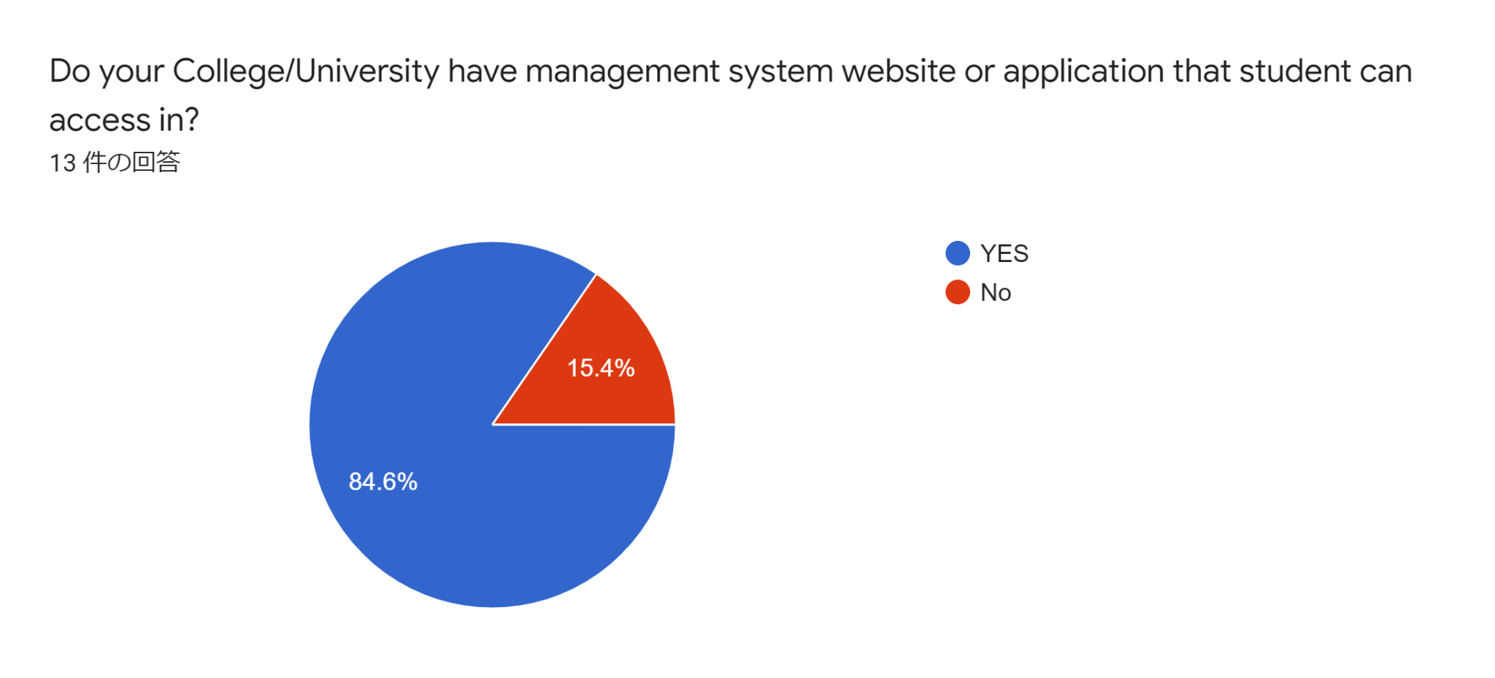

For Q13

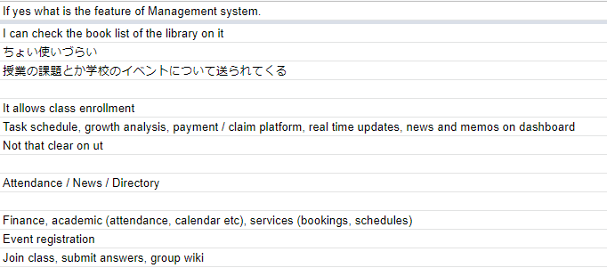

2nd row: irrelevant answer

3rd row: assignment and event announcement are shared by the management system.

From all the feedback from above

I created user story mapping

